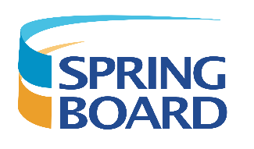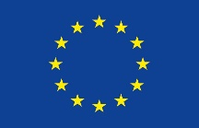
Agenda for face-to face meeting of SPRINGBOARD project,
November 23-24, 2021
November 23th
Partner consortium meeting (hotel Grand Poet)
12:00 - 18:00 Meeting in hotel
-) Actualities of SPRINGBOARD project progress,
-) Arranging the date and scientific programme of summary school 2022
-) Information regarding 1st period report
18:30 – 20.00 Dinner in hotel
During dinner project consortium partners discussed about progress of co-authored manuscript; representative of the Advisory Board Dr. Uldis Berķis provided information on the latest issues of the Horizon Europe project actualities.
November 24th
(Latvian Institute of Organic Synthesis)
9:30 – Departure from hotel to the Latvian Institute of Organic Synthesis (LIOS)
10:00 -) meeting with the director of LIOS Dr.chem Osvalds Pugovics,
-) Updating the programme of outgoing – incoming visits, meeting with visitors
-) Further joint activities
11:00 – 13.00 Visit to laboratories/core facilities of LIOS

This project has received funding from the European Union’s Horizon 2020 research and innovation programme under grant agreement No 951883

